North East University Bangladesh
Department of Computer Science and Engineering



BEST ORGANIZTION

By
Md. Ruhul Alom
Reg. No: 170103020046
BSc(Engg) in CSE
4th year 2nd semester

Supervised By
Shahadat Hussain Parvez
Lecturer
Department of Computer Science and Engineering

27th October, 2020

BEST ORGANIZTION

A Project submitted to the Department of Computer Science and Engineering,
North East University Bangladesh, in partial fulfillment of the requirements
for the degree of Bachelor of Science in Computer Science and Engineering

By
Md. Ruhul Alom
Reg. No: 170103020046
BSc(Engg) in CSE
4th year 2nd semester

Supervised By
Shahadat Hussain Parvez
Lecturer
Department of Computer Science and Engineering

27th October, 2020
Recommendation Letter from Thesis Supervisor

These Students, Md. Ruhul Alom, whose project entitled “Best Organization”, is under my supervision and agrees to submit for examination.

Signature of the Supervisor ：

Shahadat Hussain Parvez
Lecturer
Department of Computer Science and Engineering
North East University Bangladesh

Qualification Form of BSc(Engg) Degree

Student Name： Md.Ruhul Alom
Project Title： Best Organization

This is to certify that the project is submitted by the student named above in October, 2020. It is qualified and approved by the following persons and committee.

Head of the Dept.  Tasnim Zahan  Assistant Professor  Department of CSE  North East University Bangladesh | Supervisor  Shahadat Hussain Parvez  Lecturer  Department of CSE  North East University Bangladesh

Abstract

Best Organization is a review type of website where a visitor can read various type of organization information and can share their opinion about this organization through comment and ratting. We have done the requirement analysis through various website and people. In this website it will show the most rated organization by category based on user rating. Now a day’s many Organization are running with various service, through this website we want to make communication between service provider, organization, and service taker, user or people.

Table of Contents

Table of Contents
Abstract i
Table of Contents ii
List of Figures ii
INTRODUCTION 1
1.1 Project Overview 1
1.2 Purpose of the Project 1
1.3 Goal of the Project: 1
BACKGROUND STUDY 2
2.1 Overview 2
2.2 Current situation 2
These type of website are available in our country and people are using these type of website and most common thing is people can share their opinion and give feedback through this type of website. I search Google to find same sort of website but it is rare to find same exactly same website but I find some organization which has own review system. The specialty of this website is to come most of the organization in one platform for user feedback and review. 2
REQUIREMENT ANALYSIS 3
3.1 Overview: 3
3.2 Data Requirement: 3
3.2.1 Admin 3
3.2.1 Sign Up 3
3.2.2 Organization Information 3
3.2.3 Category 3
3.2.4 Review and Rating 4
3.2.5 HR blog: 4
3.2.6 Request for organization Inclusion: 4
FUNCTIONALITIES 5
4.1 Overview: 5
4.2 Functional requirement: 5
4.3 Non-functional requirement: 5
ERD AND DATABASE DESIGN 6
TOOLS USED 7
6.1 Overview: 7
6.2 Tools used: 7
6.2.1 HTML, CSS: 7
6.2.2 Bootstrap and JavaScript: 7
6.2.3 PHP: 7
6.2.3 MySQL: 7
FUTURE WORK 8
7.1 Overview: 8
7.2 Future work: 8
8.1 Conclusion: 9
REFERENCE 9

List of Figures
Figure 1: Enhancement using the proposed method 5

Chapter 1

INTRODUCTION

Project Overview
The project is an organization review site, where a user can give feedback various type of organization for developing their service and appreciate their good work. In time of Internet people are more biased by the people opinion and this site will help people to find good organization where they can trust and can get service from this organization. This website will make an intercommunication between organization and their service holder.

1.2 Purpose of the Project
- To make a user friendly review site.
- User can easily get information about his local organization.
- To know the importance about review site in organizational sector.
- User can easily chose good organization based on the people feedback.
- Organization can improve their service and product based on the people feedback.
- Organization can easily notify their strong and weak side.
- To make interactive communication between user and organization.

1.3 Goal of the Project:
The main goal of the project to make a fruitful interconnection with User and Organization where a user can easily chose best organization for his desired service based on organization information and people feedback. Furthermore an organization can easily know their condition by people judgment which can help them to work on their week side and improve their strong side from other competitive organization .In addition using HR blog human recourse managers can communicate one another along with user by sharing idea and own organization related information.

Chapter 2

BACKGROUND STUDY

Overview
We have analyzed by visiting various type of review website for our background study. We meet some owner of organization to know their requirement if proposed website (Best organization) is made. Furthermore we visited some renewable organization website to see their own customer review system and try to find how they deal with user feedback

Current Situation
These type of website are available in our country and people are using these type of website and most common thing is people can share their opinion and give feedback through this type of website. I search Google to find same sort of website but it is rare to find same exactly same website but I find some organization which has own review system. The specialty of this website is to come most of the organization in one platform for user feedback and review.

Chapter 3

REQUIREMENT ANALYSIS

3.1 Overview:
For requirement analysis we have done it in 3 sub part,
- Firstly visited many website to get the knowledge about the project.
- Analyze the data and information to find different type of requirement for the system.
- Talk some organization owner and general people to collect specific requirement.
- From these information designed ERD and Database.

Data Requirement:

3.2.1 Admin:
Here for this website admin can be the manager of this website. Admin can edit/update/delete of any post or content which is either HR. blog post or other Organization information. Admin has authorization to approve or reject any post and user request .The Admin information contain email and password.

3.2.2 Sign Up:
Sign up is the option through which we will get the information of the user which information we can use for other program. For viewing sign up is not required but for comment and rating sign up is necessary.

3.2.3 Organization Information:
A user can easily show various type of organization and they’re could be a little bit description with rating in the front page. There would be most rated organization in every month based on user feedback and rating.

3.2.4 Category:
In category various type of organization will divide on various category. For example, Textile organization are put into garments category.

3.2.5 Review and Rating:
A register user can give feedback through commenting and ratting .In rating system it would start one and end with five. This system will contain user information and show it on comment and review section.

3.2.6 HR blog:
In HR blog, where various organization human resource manager can write blog and share information with user and HR manager will show it and allow to give feedback.

3.2.7 Request for organization Inclusion:
User and HR can apply for organization inclusion on the website .where user can only suggest any organization inclusion by putting name and website link. But HR of the organization can apply for his organization by providing all require information. After admin approval it would be included on website basis on HR information.

Chapter 4

FUNCTIONALITIES

4.1 Overview:
We have divided our functional requirement in two part
- Functional requirement
- Non-Functional requirement

4.2 Functional requirement:
- A register user can suggest organization name to include on website and Organization HR representative can apply for organization inclusion on website by giving organization information.
- A user and HR can register by putting their name, email, password and profile picture in the registration area.
- Store the user information.
- Every kind of register user can edit, and update their information.
- Giving feedback a user must sign in through user email and password.
- Admin can approve, reject, edit or delete any kind of content, blog, user request and organization request.

4.3 Non-functional requirement:
- Usability
- Reliability
- Performance
- User Interface
- Storage back up

Chapter 5
ERD AND DATABASE DESIGN

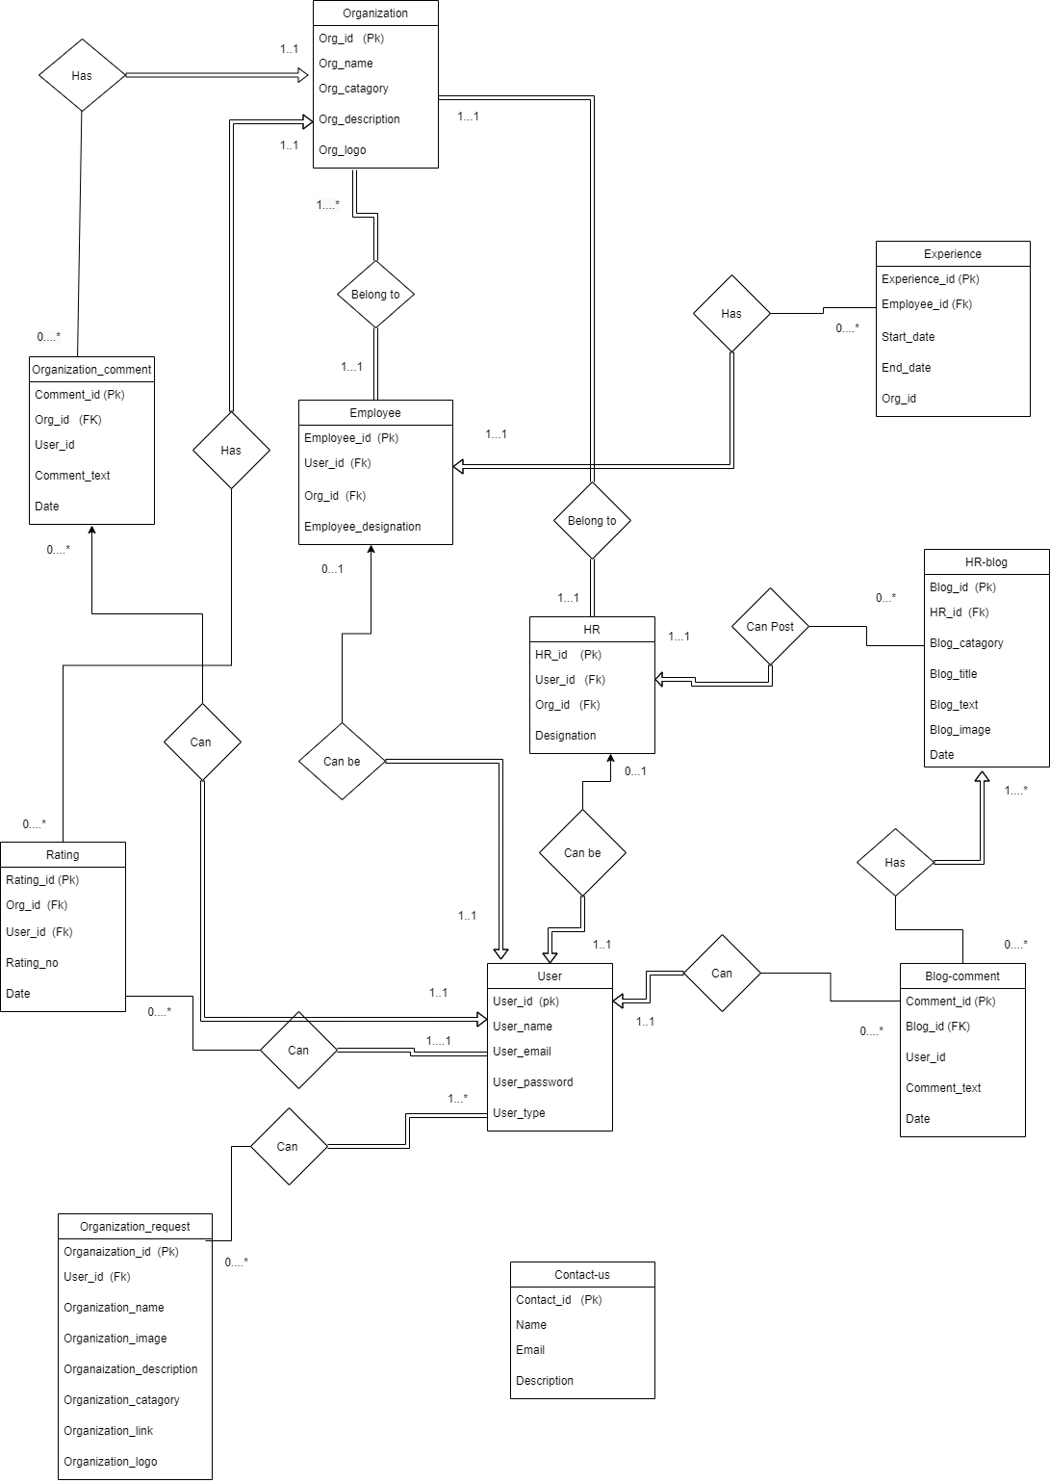

Chapter 6

USER INTERFACE DESIGN

6.1 User Interface:
We build this website for making intercommunication between user and organization .In the below section I will demonstrate some user interface of this website
    - Admin

Chapter 7

TOOLS USED

7.1 Overview:
In this chapter I will discuss about tools which I used to develop this website

7.2 Tools used:

7.2.1 HTML, CSS:
Basically HTML and CSS are mostly used in designing part which are called front-end designing. Here we used HTML and CSS for our front end designing part. HTML used for coding of design and we used CSS for making the website attractive and user friendly.

7.2.2 Bootstrap and JavaScript:
Here we use Bootstrap and JavaScript for making this website more responsive, efficient and attractive along with user friendly design.

7.2.3 PHP:
I used PHP for designing my backend part that was implemented by row codding of PHP which is used to make dynamic and more efficient for user.

7.2.3 MySQL:
MySQL is open source relational database management system based on structure query language (SQL) I used SQL for designing my database for this website.

Chapter 8

FUTURE WORK

8.1 Overview:
Here I will discuss about feature work of my project. That means which work I will finish after this semester.

8.2 Future work:
- First of all I will complete my remaining user Interface
- Then I will work on backend for these user interface
- After that I will test the whole project
- Then debugging error if any error find solve it before deploying to the user.

Chapter 9

CONCLUSION

9.1 Conclusion:
Best Organization is a web based review site. Our main goal to make interaction between user, organization and human resource section. We have already completed our front end site. Some other user interactive work along with backend development will be completed in future .Now a days people are passed their time using internet and want to suggest other people opinion this site will help to people to find best organization along with their facility .

REFERENCE

- https://www.w3schools.com
- https://www.youtube.com/
- https://stackoverflow.com.
- https://www.javatpoint.com
- https://github.com

